Lab 4 - VLAN and VTP configuration

Lab instructions

The aim of this lab is to check your ability to configure VTP and VLAN on a small network of four switches. This lab will help you to prepare your ICND1 exam.

1.Configure the VTP-SERVER switch as a VTP server  
  
2.Connect to the  3 other switches and configure them as VTP clients.  
All links between swiches must be configured as trunk lines.  
  
3.Configure VTP domain name as "TESTDOMAIN" and VTP password as "cisco"  
  
4.Configure VLAN 10 with name "STUDENTS" and VLAN 50 with name "SERVERS"  
  
5. Check propagation on all switches of the VTP domain.

Network diagram

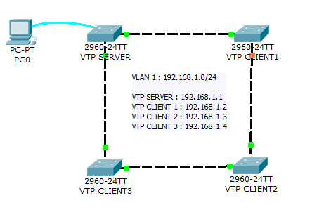

Solution

**Configure the VTP-SERVER switch as a VTP server**

VTP-SERVER(config)#vtp mode server

Verify the VTP configuration using the "show vtp status command"

VTP-SERVER#show vtp status   
VTP Version                     : 2  
Configuration Revision          : 4  
Maximum VLANs supported locally : 255  
Number of existing VLANs        : 7  
VTP Operating Mode              : Server  
VTP Domain Name                 : TESTDOMAIN  
VTP Pruning Mode                : Disabled  
VTP V2 Mode                     : Disabled  
VTP Traps Generation            : Disabled  
MD5 digest                      : 0xAE 0x4F 0x3F 0xC5 0xD3 0x41 0x9C 0x11   
Configuration last modified by 192.168.1.1 at 3-1-93 00:27:41  
Local updater ID is 192.168.1.1 on interface Vl1 (lowest numbered VLAN interface found)

**Connect to the  3 other switches and configure them as VTP clients.   
All links between swiches must be configured as trunk lines.**

VTP-CLIENT3(config)#vtp mode client

Verify the VTP configuration using the "show vtp status command"

VTP-CLIENT3#sh vtp status  
VTP Version                     : 2  
Configuration Revision          : 4  
Maximum VLANs supported locally : 255  
Number of existing VLANs        : 7  
VTP Operating Mode              : Client  
VTP Domain Name                 : TESTDOMAIN  
VTP Pruning Mode                : Disabled  
VTP V2 Mode                     : Disabled  
VTP Traps Generation            : Disabled  
MD5 digest                      : 0xAE 0x4F 0x3F 0xC5 0xD3 0x41 0x9C 0x11   
Configuration last modified by 192.168.1.1 at 3-1-93 00:27:41

**Configure VTP domain name as "TESTDOMAIN" and VTP password as "cisco"**

1. Configure each link between switches as a trunk line

interface GigabitEthernet1/1  
switchport mode trunk  
  
interface GigabitEthernet1/2  
switchport mode trunk

2.On the server :

VTP-SERVER(config)#vtp domain TESTDOMAIN

VTP-SERVER(config)#vtp password cisco

3.On each client :

VTP-CLIENT1(config)#vtp password cisco

VTP-CLIENT1(config)#vtp domain TESTDOMAIN

**Configure VLAN 10 with name "STUDENTS" and VLAN 50 with name "SERVERS"**

On the VTP server switch, configure the following commands

VTP-SERVER(config)#vlan 10

VTP-SERVER(config-vlan)#name STUDENTS

VTP-SERVER(config)#vlan 50

VTP-SERVER(config-vlan)#name SERVERS

**Check propagation on all switches of the VTP domain.**

Use the "show vlan brief" on each switch to check propagation of the 2 VLANS.

VTP-SERVER#show vlan brief  
  
VLAN Name                             Status    Ports  
---- -------------------------------- --------- -------------------------------  
1    default                          active    Fa0/1, Fa0/2, Fa0/3, Fa0/4, [...]  
10   STUDENTS                         active      
50   SERVERS                          active      
1002 fddi-default                     active      
1003 token-ring-default               active      
1004 fddinet-default                  active      
1005 trnet-default                    active